**Happy Online Store**

**User Guide**



**By**

**Mohamed Abulgasem, Keenan Cookson and Muhammad Zuhayr Davids**

**Introduction**

Happy Online is an online store that sells a variety of surfboards and wetsuits. It is made with a simplistic approach. This quick guide will show you how to register, login and purchase a product.

The first step is visiting the website, the home page will be displayed with the shopping cart at the top right hand corner along with the register and login links. Click on the "Register" link.



Once you have clicked on the "Register button" you can now fill in your details such as name, surname, phone number, email address; and password. All fields are required.

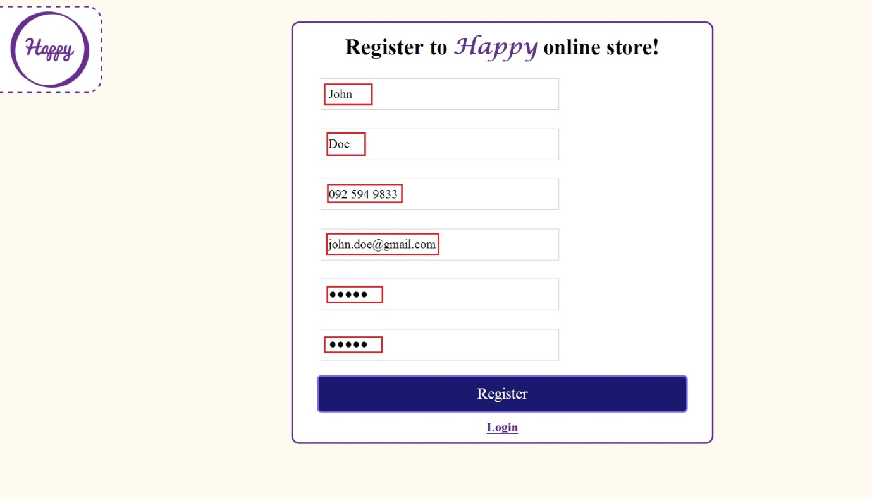

Once you have filled in your details you can click on the "Register" button which will take you to the login page with a message thanking you for registering. Fill in the field with your email address and password that you have provided in the register page.

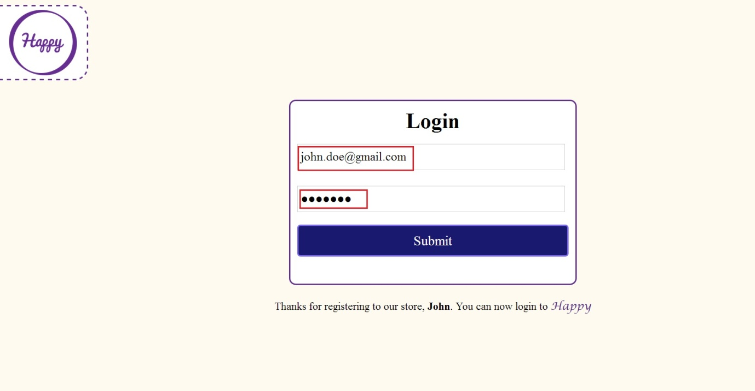

You are now logged in and on the home page again, go to either the surf boards or wet suits page.



On the surf boards or wet suits page you should see different related products and be able to add a quantity to the cart. Add an item to the cart.

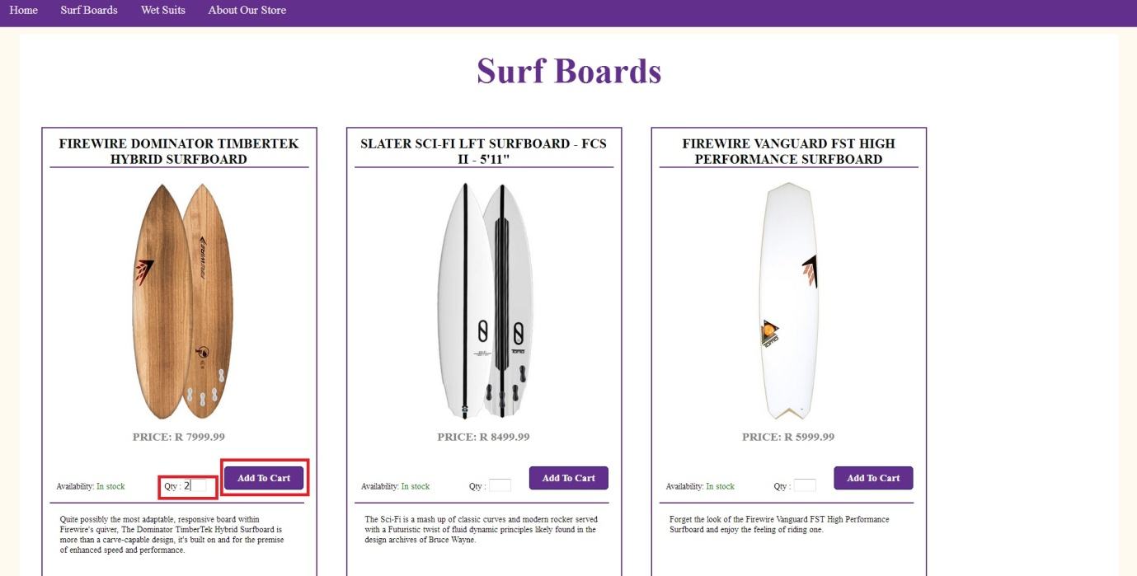

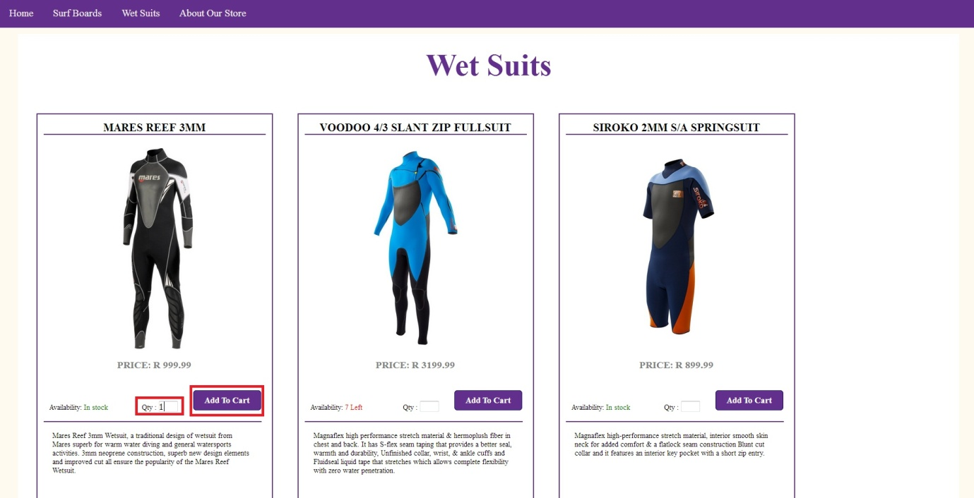

You can click on the shopping cart picture at the top right hand corner to view all of your items in the checkout page.

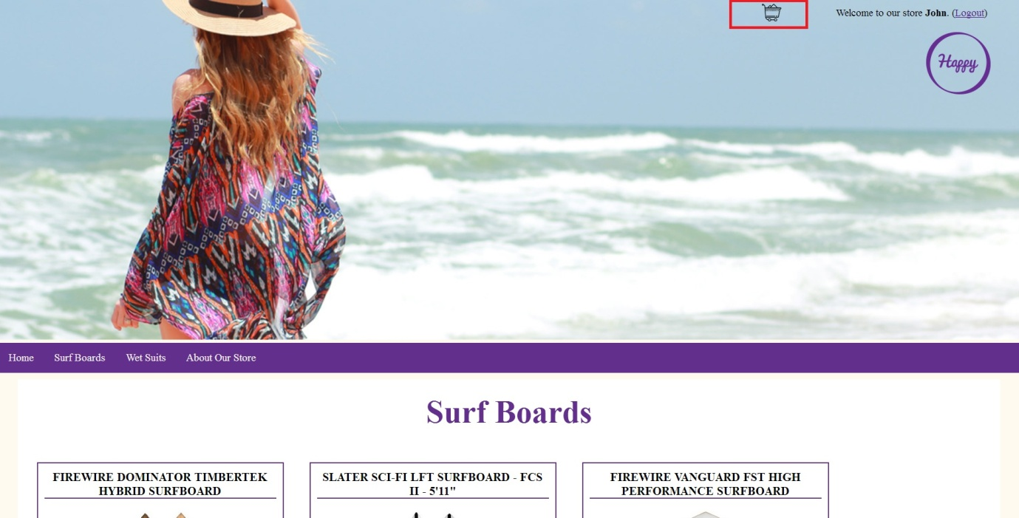

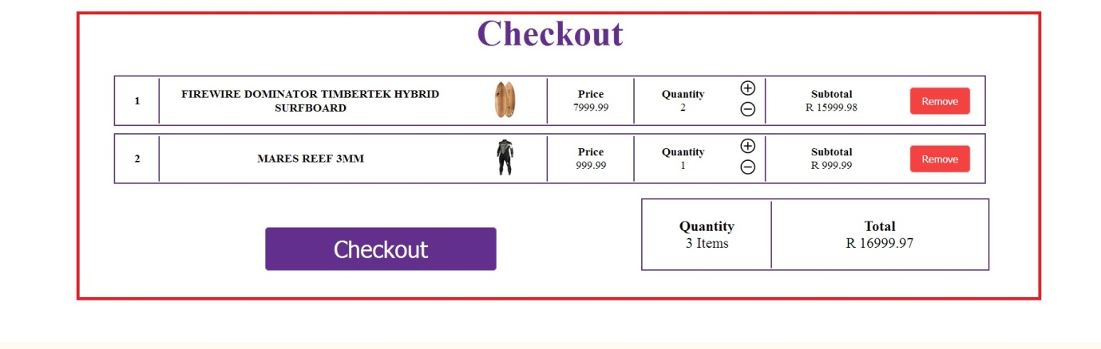

You can increase or decrease the quantity with the plus/minus buttons.

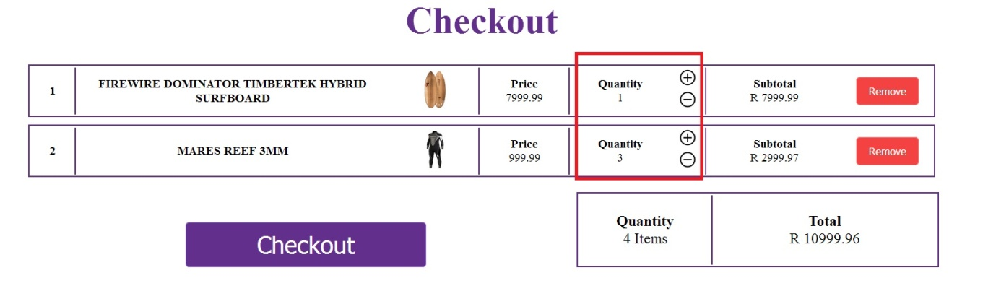

You can also remove a product from the cart by clicking on the remove button.

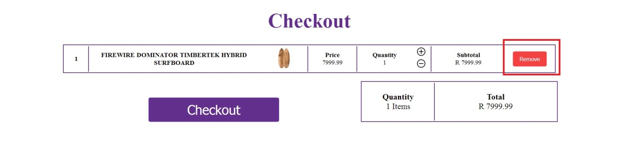

Once you have decided to purchase the products click on the "Checkout" button at the bottom of the checkout page and a confirmation message will appear.

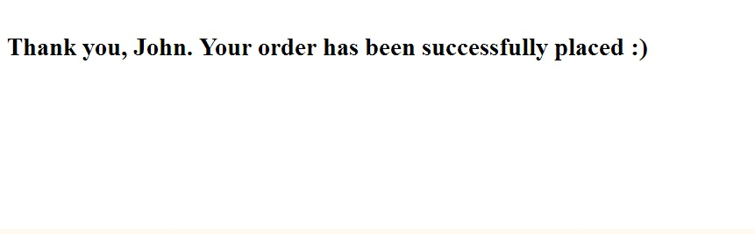

From here you can proceed to any page you wish on the website, Once you are done purchasing the products you want you can log out of the website.



At the bottom of every page is the footer with a navigation column, click on the about us page

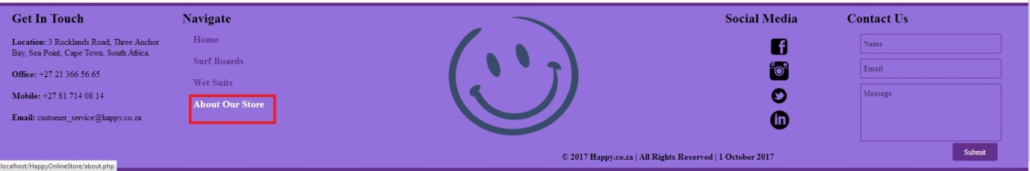

You should be at the about us page. The footer also carries multiple social media links

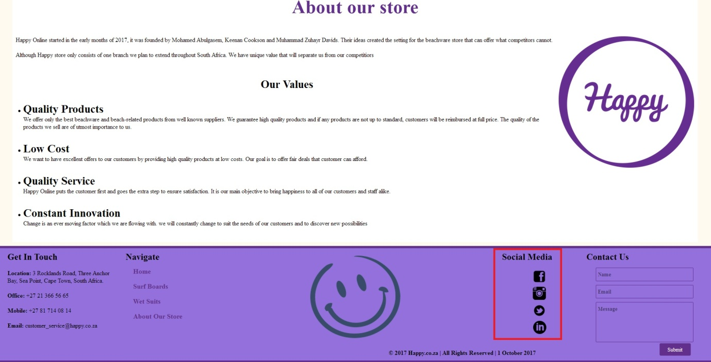

Next to the Social media links is the Contac Us section which can be used to contact the Happy Online Store. Type in your name, email address and message.

